Lesson 33: Extreme living

Discuss

What's the coldest place/city you know?
What's the biggest city you went to?
What's the hottest country you went to?

You are going to read a text about the coldest, highest and hottest places in the world.
Choose the correct alternative.

(menu: The coldest, The hottest, The highest) country in the world.
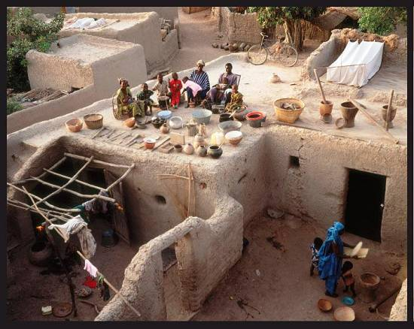

(menu: The coldest, The hottest, The highest) capital city in the world.
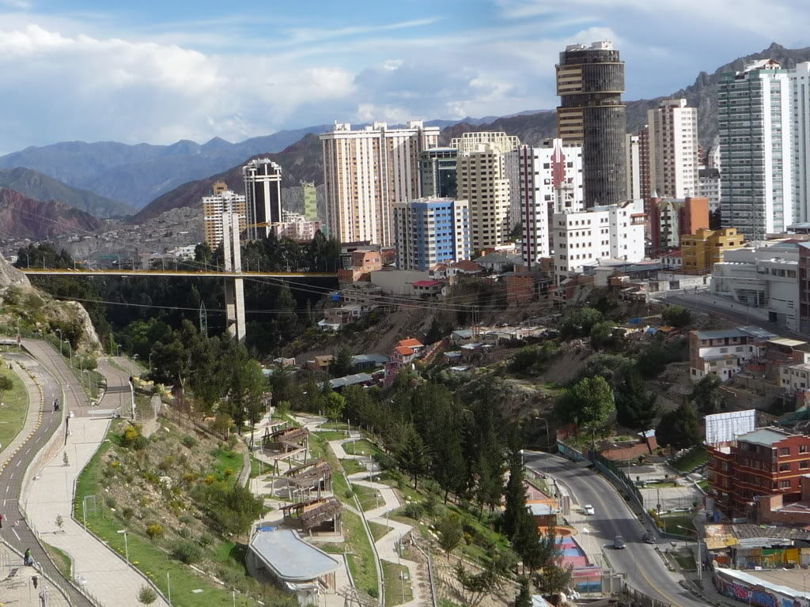

(menu: The coldest, The hottest, The highest) place in the world.
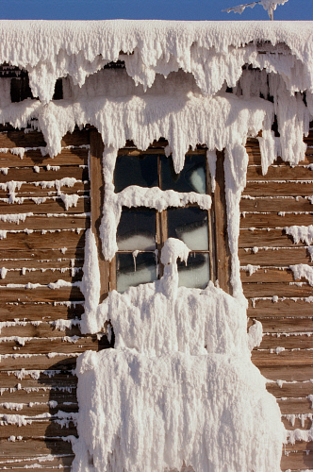

Answer the questions about the article by choosing the name of a place.

- Where do people wear a lot of cotton clothes? In (menu: Mali, La Paz, Yakutia)
- Where is a good place to play golf? (menu: Mali, La Paz, Yakutia)
- Where do people sleep on the roof? In (menu: Mali, La Paz, Yakutia)
- Where can you have a problem with your nose? In (menu: Mali, La Paz, Yakutia)
- Where do you need to be careful in spring? In (menu: Mali, La Paz, Yakutia)
- Where is a bad place to drink a lot of alcohol? (menu: Mali, La Paz, Yakutia)

Focus on the following sentences.

Yakutia is colder than La Paz. Yakutia is the coldest place in the world.
Mali is hotter than La Paz. Mali is the hottest country in the world.
The spring is the most dangerous time in Yakutia because the ice can kill people!


Look at the information in the chart.

Write superlative sentences using the information and the following adjectives:

BIG - SMALL - POPULAR - CHEAP - EXPENSIVE - BEAUTIFUL

For example,
The Rio Club is the biggest.

Write questions about your country using the prompts.

For example,

What's the wettest place?
What's the hottest place?

Now answer the questions about your country.

I think ...
Perhaps / Maybe ...

AVISO IMPORTANTE

Estimados alumnos:
Les informamos que ésta es la última clase del nivel con contenidos nuevos, por lo que les recomendamos comenzar a repasar todos los temas estudiados hasta el momento. Las próximas clases serán de repaso para en la ultima realizar una evaluación final.
Atentamente,
Curso AEANA

PRACTICE

http://elt.oup.com/student/englishfile/elementary/a_grammar/file08/grammar08_b01?cc=ar&selLanguage=en

http://elt.oup.com/student/englishfile/elementary/a_grammar/file08/grammar08_b02?cc=ar&selLanguage=en

