Vocabulary: How much is it?

England

The USA

Europe

Argentina

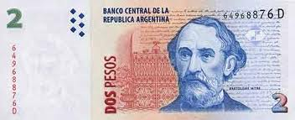

two pesos

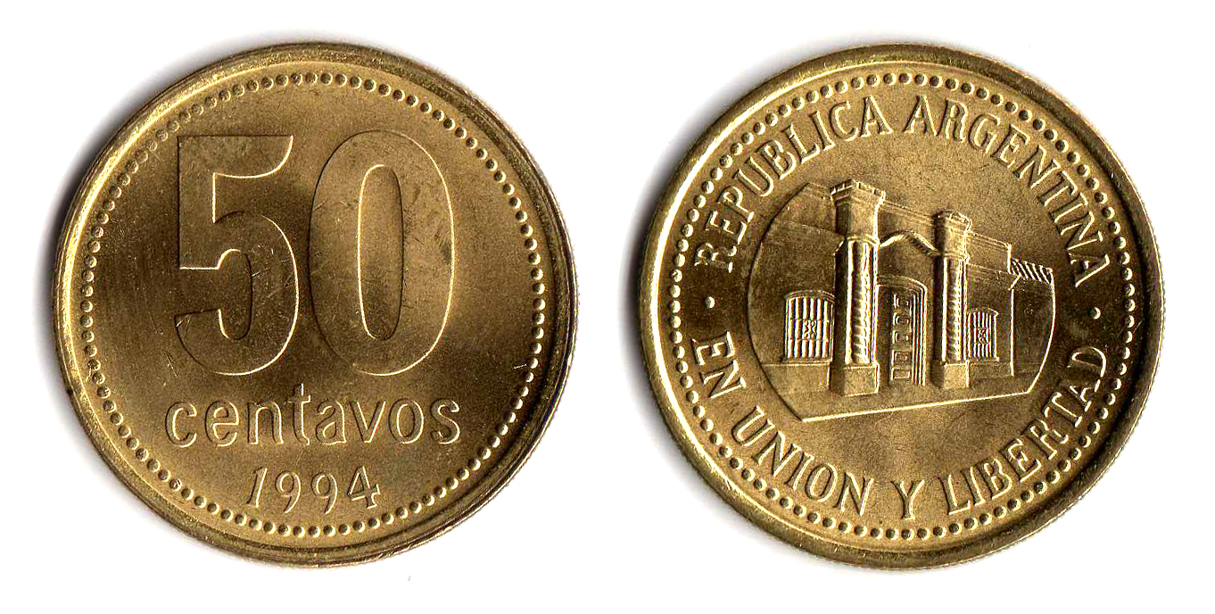

fifty cents

How we say prices

- Don't use and between pounds and pence, dollars and cents, euros and cents or pesos and cents.
For example,
£ 2.50 two pounds fifty
€ 9.70 nine euros seventy
$ 49.99 forty-nine dollars ninety-nine
$ 110.50 a hundred and ten pesos fifty

- Use the word pence or cents for an amount that is less than 1 pound / dollar / peso / euro.
For example,
£ 0.40 forty pence / forty p
€ 0.99 ninety-nine cents
$ 0.43 forty-three cents
$ 0.75 seventy-five cents


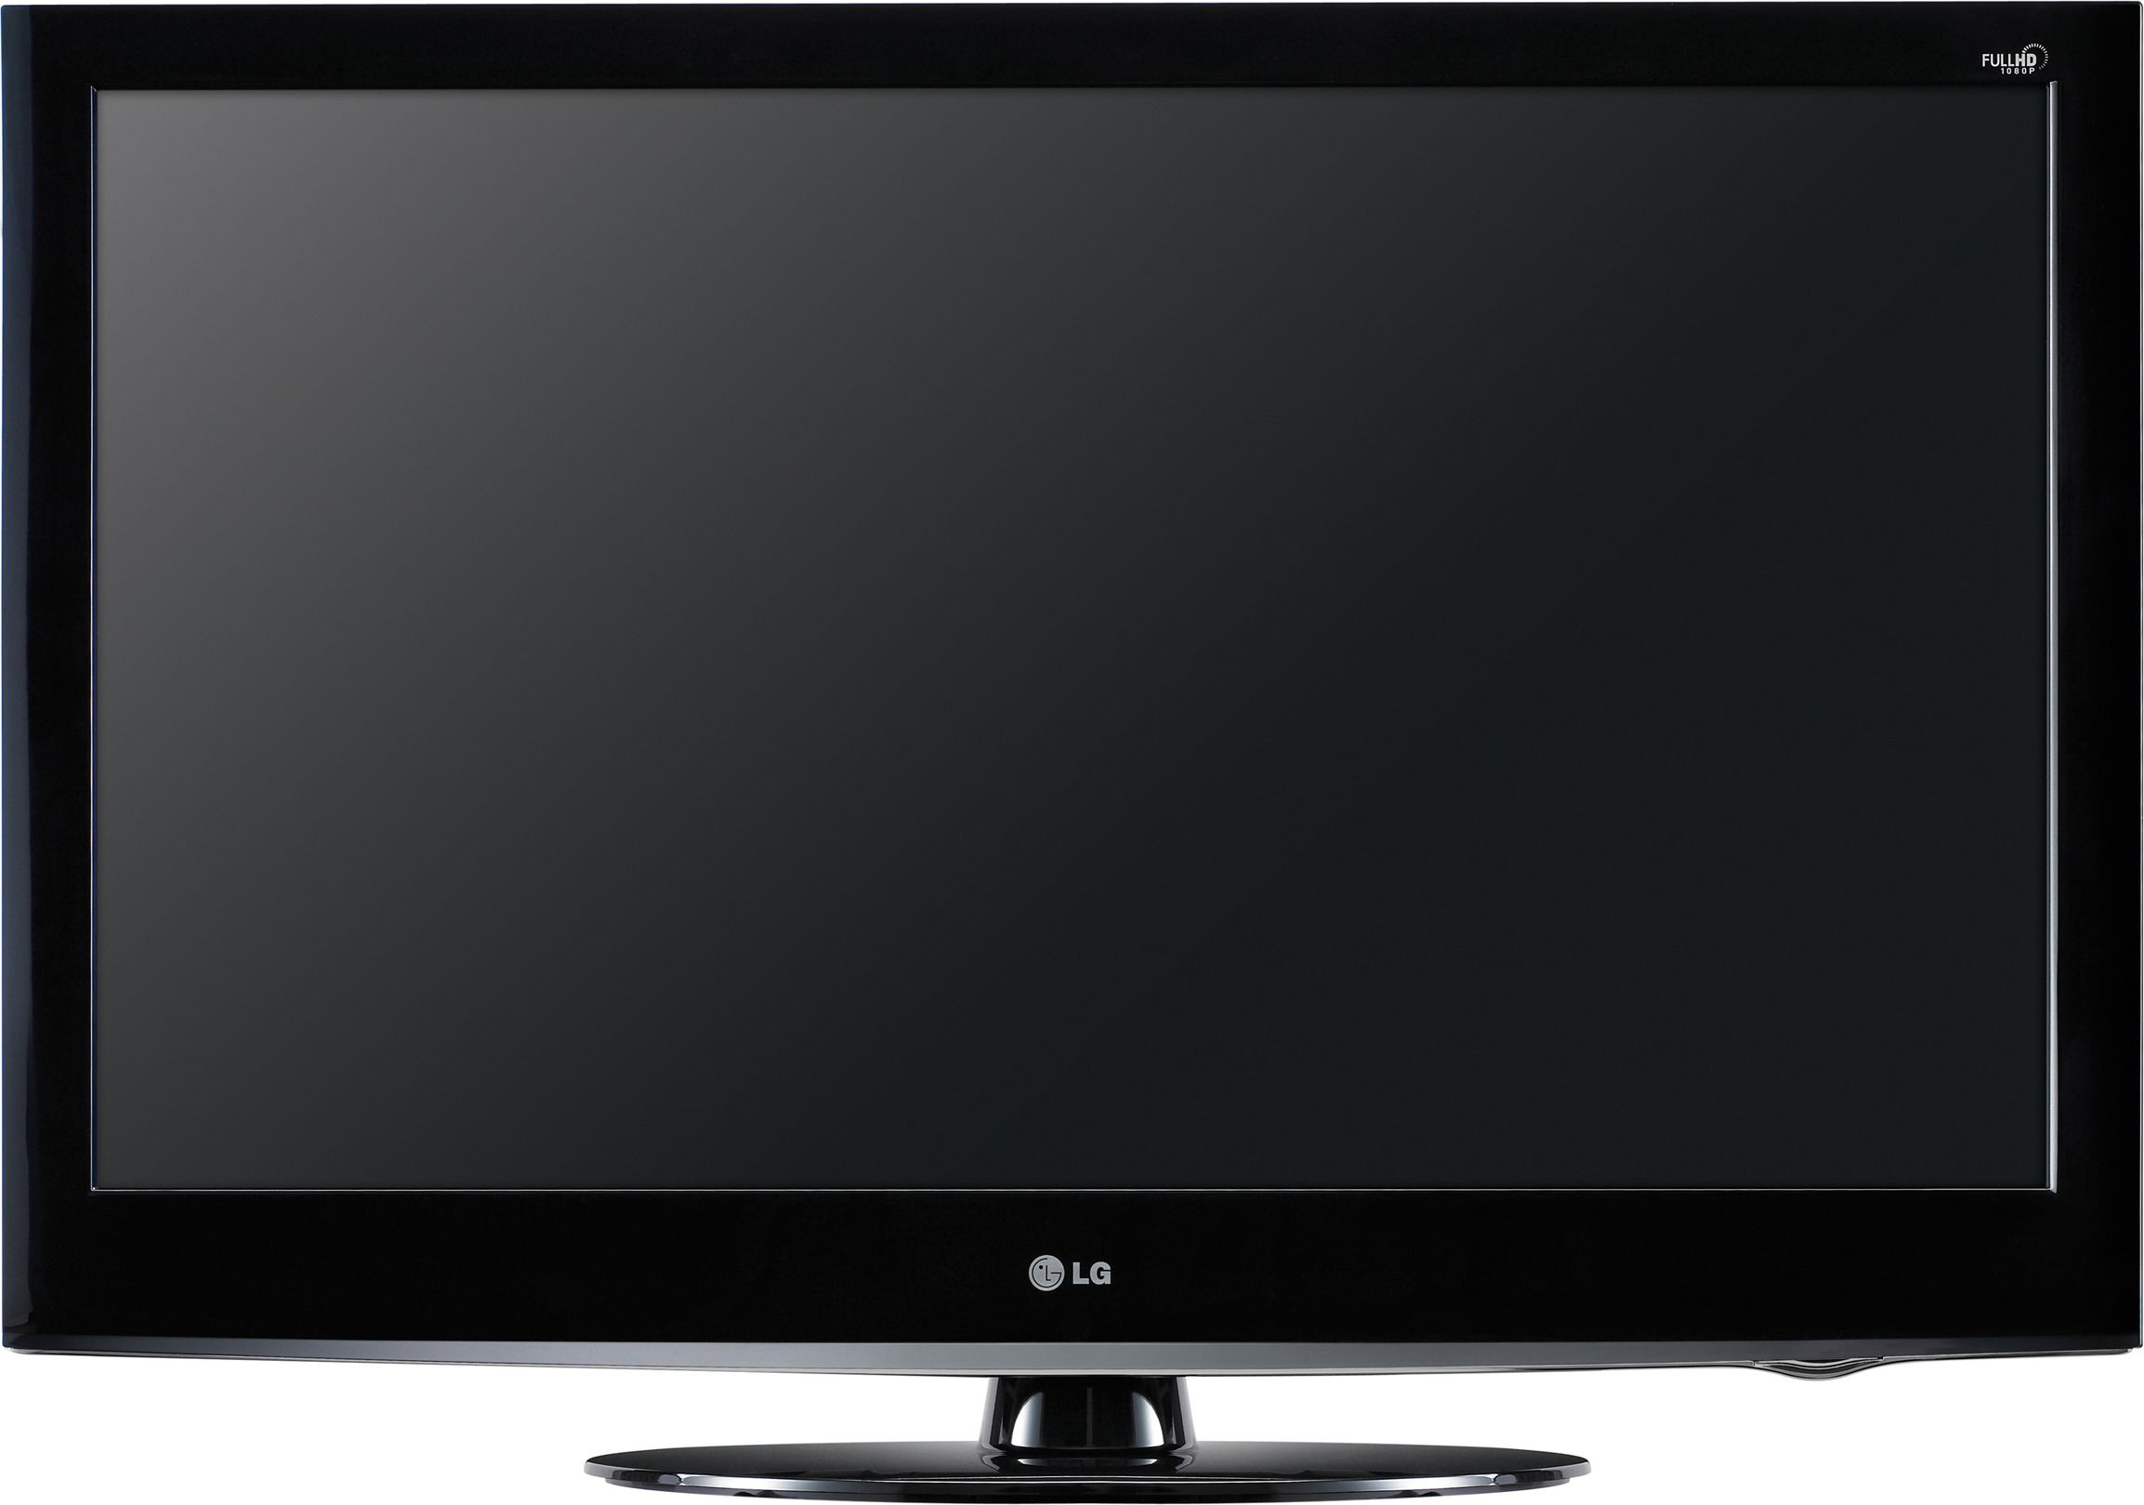
REMEMBER!

How much is this TV?
It's $4.000. (singular)



How much are these jeans?
They're $400. (plural)

