Grammar: Buying coffee

Read the dialogue

Barman Can I help you?
Woman Yes, can I have a coffee and a chocolate brownie, please?

Barman Espresso, Americano, cappuccino?
Woman An espresso, please.
Barman Single or double?
Woman Single. How much is that?
Barman Two pounds forty-five.
Woman Here you are.
Barman Thanks.

Focus on the language for buying coffee.

- The barman/barwoman says: Can I help you?
This is what you will hear first.
- When you order your food say: Can I have ...?
- Single, double, regular and large (=very big) are the different sizes of the cups of coffee/tea.
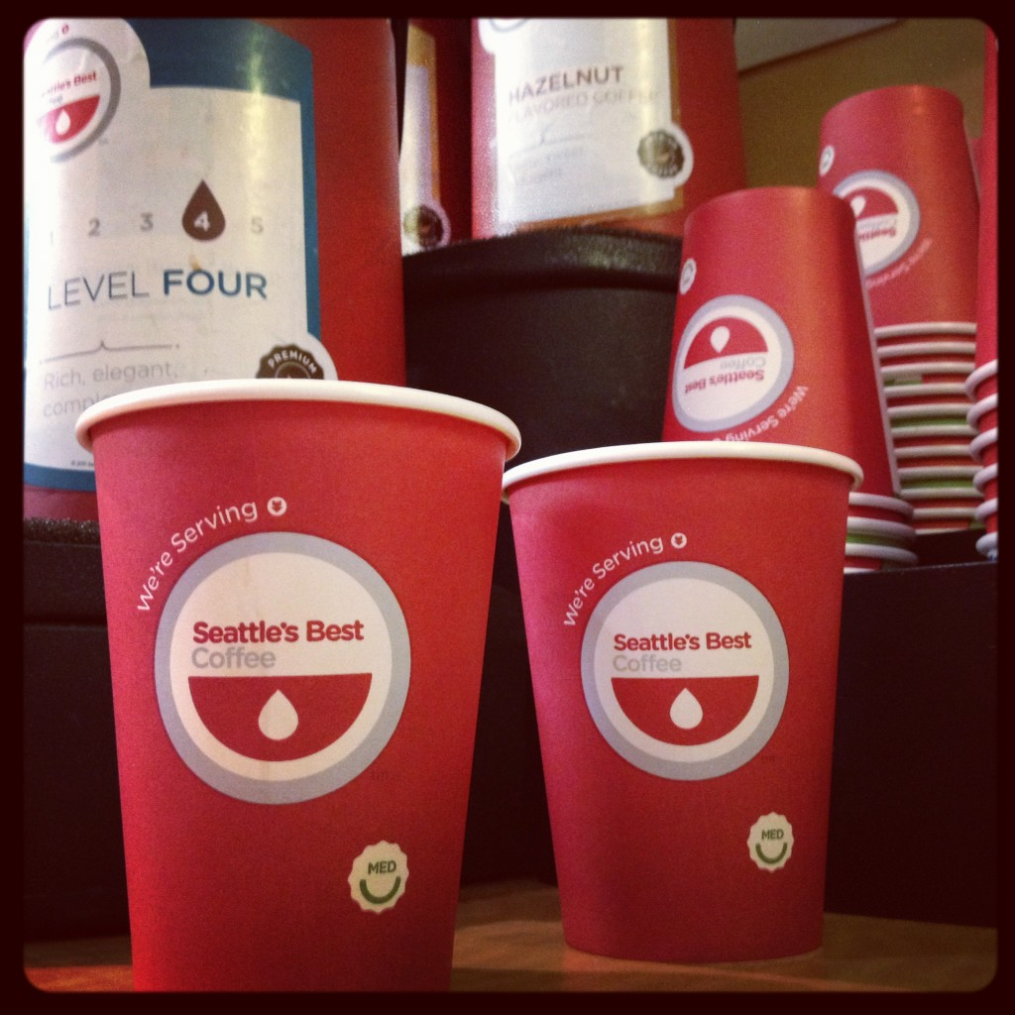


- When the barman/barwoman gives you the cup of coffee, he/she can say Here you are. When you give him/her the money or the credit card when you pay, you can say Here you are.

