Lesson 32: Babies

Think of a baby you know. Answer the questions:

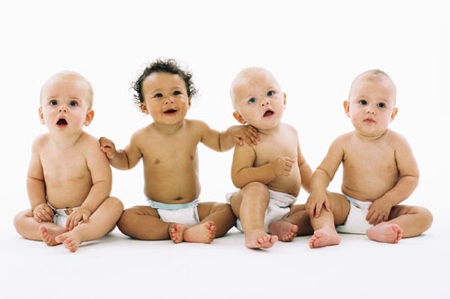

How much do you know about babies?

Complete the sentences. If you don't know, guess.

- Newborn (=new) babies sleep hours a day.

- Babies understand "no" when they are about months old.

- Babies start to use "baby talk" at about months.

- They start to crawl at about months.

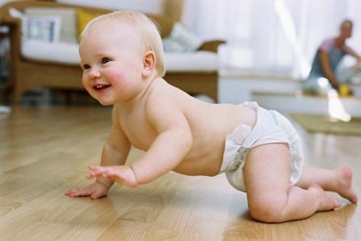
CRAWL



Read the article and check your answers in sentences 1-4. Look at the glossary.

WATCH YOUR
BABY GROW

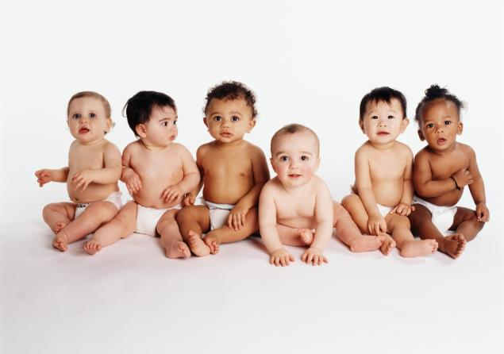

TRUE OR FALSE?

- Babies know who you are between three and six months old. (menu: TRUE, FALSE)
- They can laugh when they are about three months old. (menu: TRUE, FALSE)
- They can wave goodbye before they are a year. (menu: TRUE, FALSE)
- When they are about eight months, they can see well. (menu: TRUE, FALSE)
- They can stand without help at nine months. (menu: TRUE, FALSE)
- They learn to eat with a spoon at ten to twelve months. (menu: TRUE, FALSE)

Talking about ages.

Choose the best alternative.

- Babies (menu: can, can't) smile at about four to six weeks.
- Babies (menu: can, can't) walk when they are 5 months old.

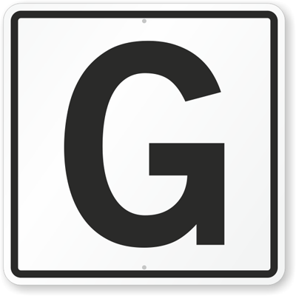

Answer the questions.

Write sentences about the following people.
1 2
3 4 5

Complete the sentences with TRUE information about you.

- I can speak (a language)

- I can't speak (a language)

- I can play (a sport / a musical instrument)

- I can't play (a sport / a musical instrument)

- I can cook (a dish)

- I can use (a machine)

- I can't use (a machine)

- I can

- I can't

PRACTICE

http://elt.oup.com/student/naturalenglish/elem/a_grammar/unit10/ne_elem_grammar10_1?cc=ar&selLanguage=en&mode=hub

