Lesson 31: Travel partners

Look the pictures.

What can you see? Use adjectives to describe the places.

COMFORTABLE - NOISY - ELEGANT - HOT - FAST - CROWDED - MODERN - BORING - INTERESTING - GOOD - BAD - BIG - SMALL - OLD - EXPENSIVE - CHEAP

For example,

In picture A I can see a very fast and modern train.

Vocabulary: Opposite adjectives.

Look at this chart

ADJECTIVES | OPPOSITES
good | 1.
fast | 2.
crowded | 3.
expensive | 4.
hot | 5.
comfortable | 6.
interesting | 7.
quiet | 8.

Write the opposites. Use the words in the box.

NOISY - EMPTY - BAD - BORING - CHEAP - COLD - UNCOMFORTABLE - SLOW

Listen and check.

(track: Opposite adjectives)

Do the travel quiz

Write your answers and say why.

Listen to two people do the travel quiz. Write three answers that are the same for the woman and the man and three answers that are different for them. Are they good travel partners?

(track: Travel quiz)

Who is a good partner for you? The man or the woman? Why?

Read the sentences from the dialogue. Choose the correct alternative.

- Flying is (menu: fast, faster) than going by train.
- Summer is (menu: hot, hotter) than spring.
- A hotel is more expensive (menu: that, than) an apartment.

Listen and check.

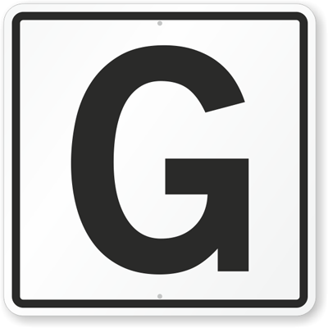
(track: Listen and check)

Write comparative sentences. Use the adjectives between brackets.

Choose two places you know (nightclubs, cities, restaurants). Which one do you like more? Write sentences about each place using comparatives.

For example,

Think about your last two holidays. Compare them. Which one was better/worse? Why? Write comparative sentences to explain your ideas.

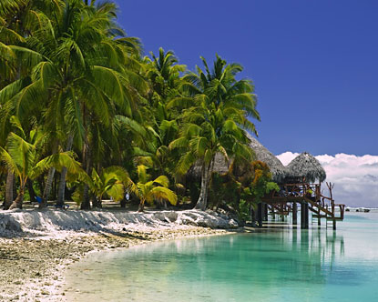
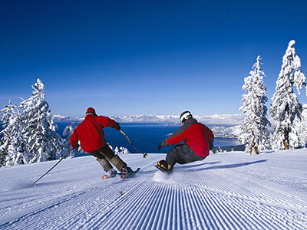

PRACTICE

http://elt.oup.com/student/result/engelem/a_grammar/unit11/11c_1?cc=ar&selLanguage=en&mode=hub

http://elt.oup.com/student/result/engelem/a_grammar/unit11/11c_2?cc=ar&selLanguage=en&mode=hub

