Lesson 25: I've read the book, I've seen the film.

HAVE YOU EVER ...?

Complete the questionnaire with the following past participles:

slept bought cried kissed left spoken seen

- Have you ever to a film actor or actress?

Who was it? What did you say?

- Have you ever a film more than three times?

What film? When was the last time you saw it?
- Have you ever in a film?

What film was it? Why did you cry?

- Have you ever a 'soundtrack' from a film?

What film was it? Who sings the song?

- Have you ever the cinema in the middle of the film?

What film was it? Why did you leave?

- Have you ever in the cinema?

What film was it? Why did you fall asleep?

- Have you ever somebody in the back row?

Who was it? Did you see the film?

Now answer the questions. If your answer is YES, I HAVE, answer the other two questions, too.

Focus on the following sentences

I've cried in the cinema three times.

I've left the cinema in the middle of a film.

My sister has seen Back to the Future more than three times.

Do we know when these actions happened exactly? (menu: YES, NO)

Read this mini-dialogue.

What tense is question A? (menu: past simple, present simple, present perfect)
What tense are questions B and C? (menu: past simple, present simple, present perfect)
Which question is general? (menu: A, B, C)
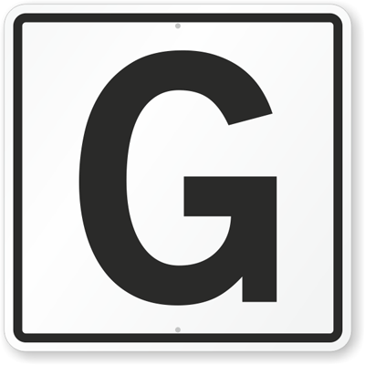
Which questions are specific? (menu: A and B, B and C, C and A)

Listen to three people answering one of the questions from the questionnaire "Cinema experiences".
Which question is it?

(track: Cinema experiences)

Listen again and answer the 3 questions about each person:

- Which film?
- How many?
- Why?

Look at these books.
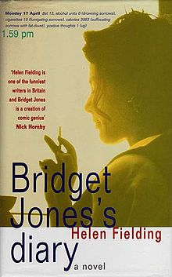
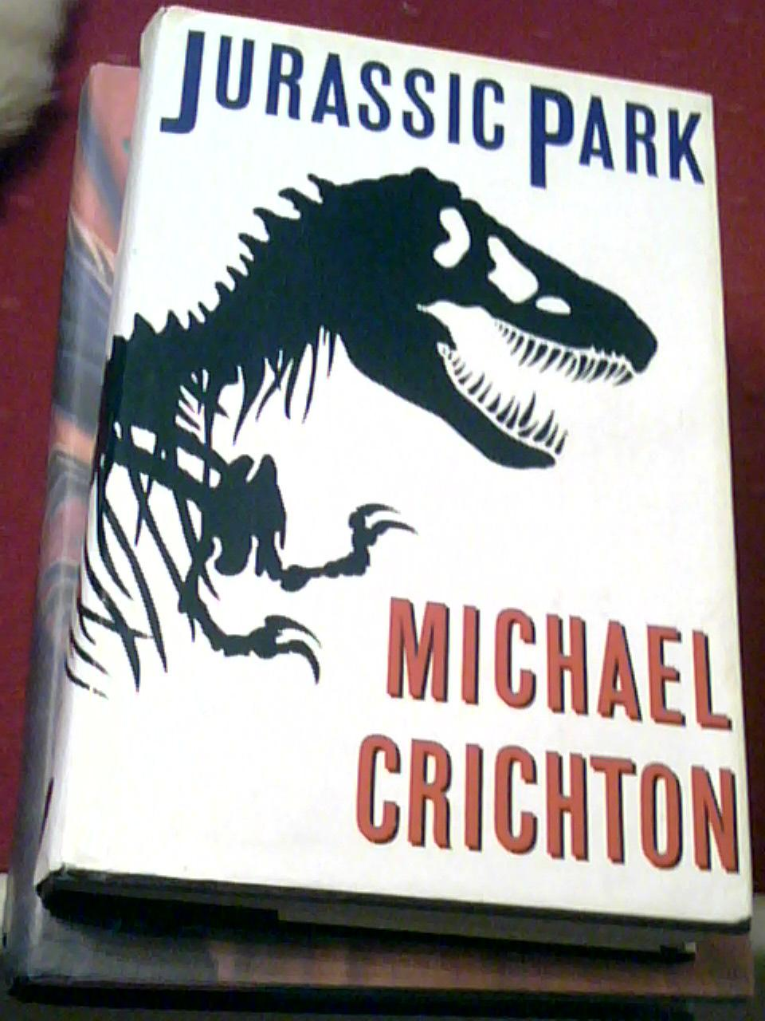
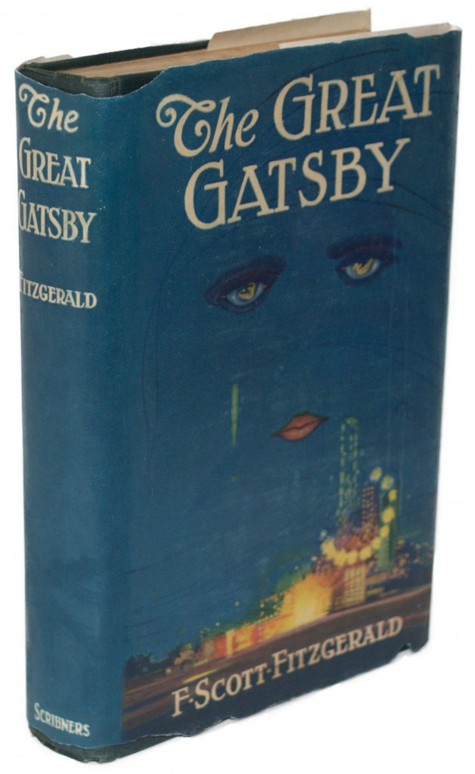
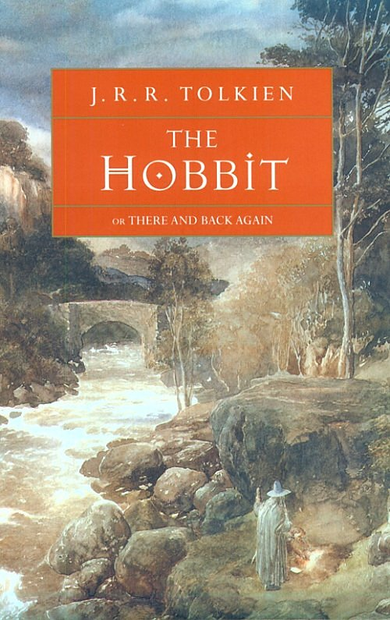

Have you read the book? Have you seen the film?

Discuss
What is better: reading the book or seeing the film? Why?
What's the best film you've ever seen? Why?
What's the worst film you've ever seen? Why?
Choose another film based on a book and compare the film and the book.

Read the article about a film adaptation of a book.

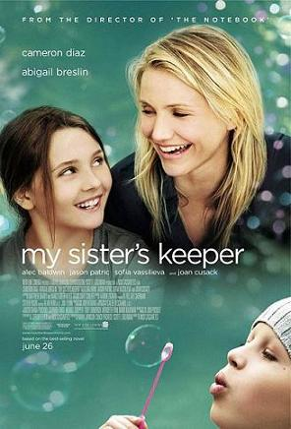
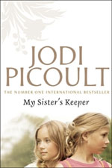

Answer the questions:

- Did fans prefer the ending of the book or the film? Why?
- Why did Anna's parents have Anna?
- What difference is there at the end of the book and at the end of the film?
- Have you seen the film?
- Have you read the book?

PRACTICE

http://elt.oup.com/student/englishfile/elementary3/grammar/file12/grammar09_a01?cc=ar&selLanguage=en

http://elt.oup.com/student/englishfile/elementary3/grammar/file12/grammar09_a02?cc=ar&selLanguage=en

