Vocabulary: Natural places

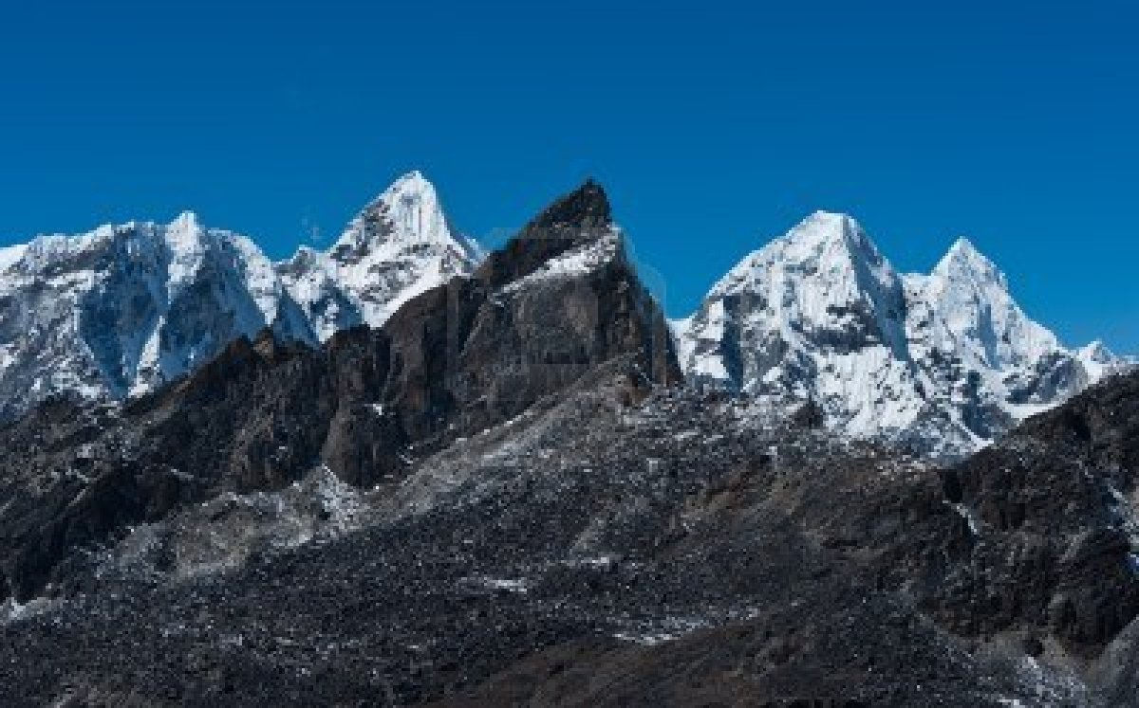
mountain range

