Lesson 28: Healthy and unhealthy living

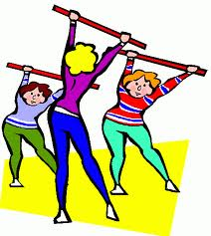
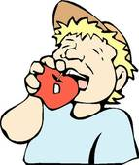
Write things that are good for you:
For example,
eat fruit
do exercise


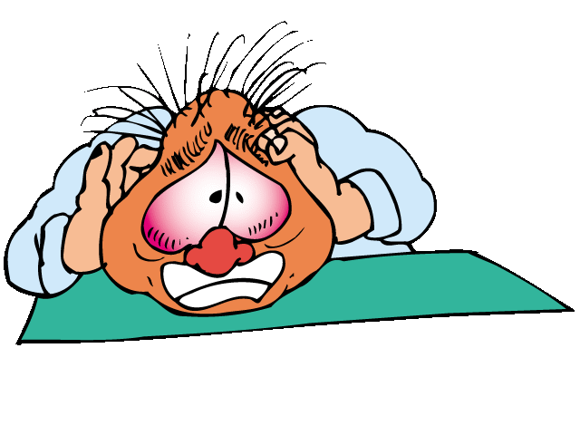
Write things that are bad for you:
For example,
smoke
stress

Look at this man. Is he a healthy person or an unhealthy person?

Imagine. What good or bad habits does he have?

Maybe he ...
I think he ...

What good and bad habits do YOU have?

Read.

TRUE or FALSE?

- People often have good intentions in April. (menu: TRUE, FALSE)
- We sometimes forget our good intentions. (menu: TRUE, FALSE)
- Good intentions are better if we are realistic, positive and think about the details. (menu: TRUE, FALSE)

Read the sentences and write: Be realistic!, Give details, and Think positive.

- I'm going to live to be 150. Be realistic!
- I'm not going to pass my exams.
- I'm going to eat healthy food.
- I'm going to do more exercise.
- I'm not going to enjoy meals.
- I'm going to win 30 Olympic gold medals.

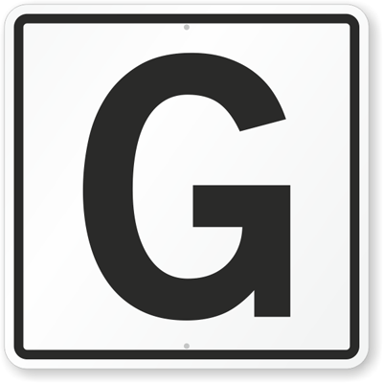

Listen and read.

(track: good intentions)

Look at the definitions of some words from Good intentions.
QUIT

FIT

WEIGHT

LESS

CHESS

STRESS-FREE

Write about your intentions for next year and for next summer.

PRACTICE

http://elt.oup.com/student/result/engelem/a_grammar/unit12/12d_1?cc=ar&selLanguage=en&mode=hub

http://elt.oup.com/student/result/engelem/a_grammar/unit12/12d_2?cc=ar&selLanguage=en&mode=hub

