Lesson 26: Video session

What's your favourite place to go for a date? Why?

A DATE = when you arrange to go out with someone you like. It's romantic.

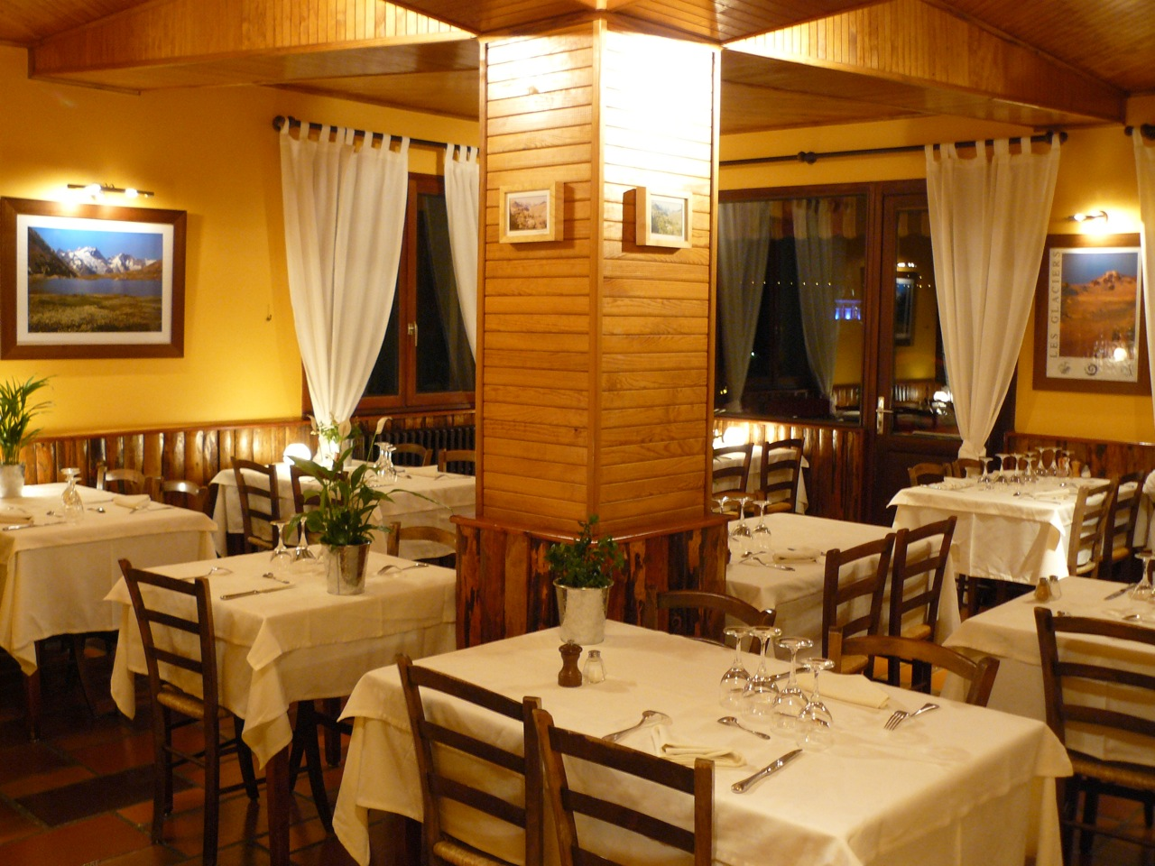

a restaurant

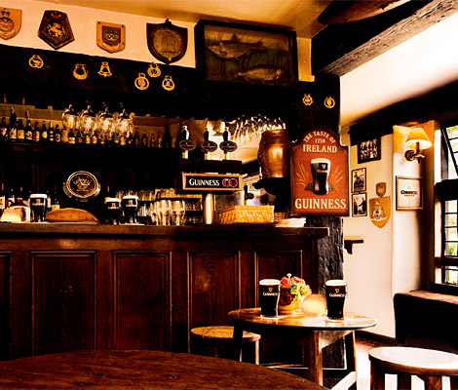

a pub / bar
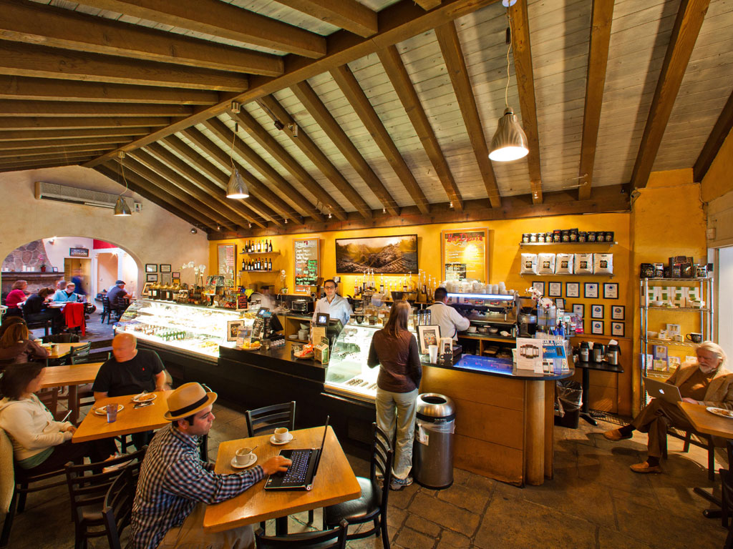

a café

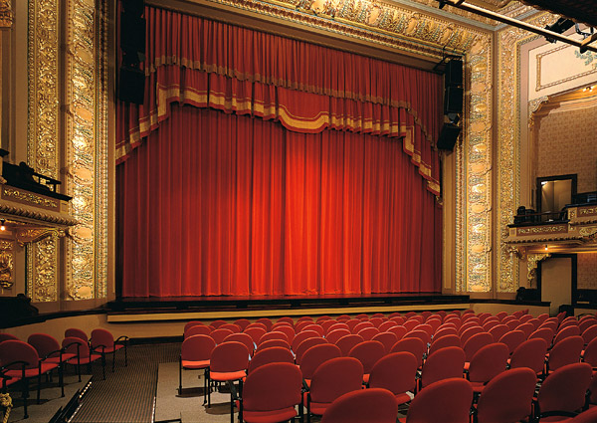

the theatre

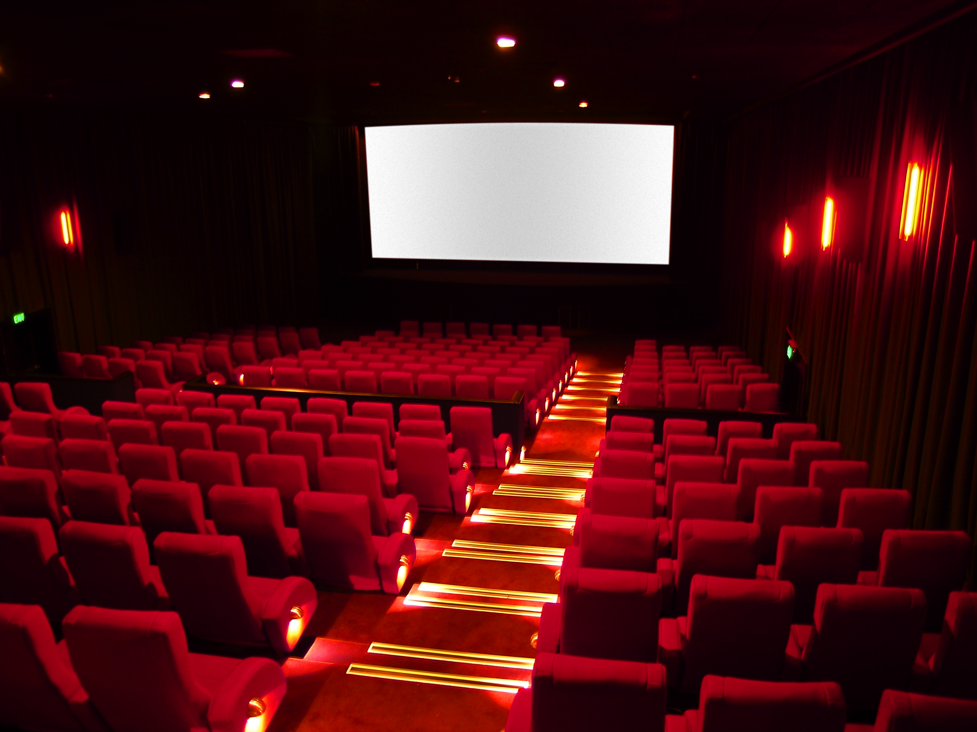

the cinema

This is David. He has a date.

Watch the video up to 1:36 and answer the questions.

- When does David have a date?
- What's the girl's name?
- When did he meet her?
- Where are they going?
- What does David think of the Hong Kong House?

http://www.youtube.com/watch?v=1x7Pca6CID8

The Chinese restaurant

Watch the video up to 2:10. TRUE or FALSE?

- Julia had an Italian meal yesterday. (menu: TRUE, FALSE)
- Julia loves Italian food. (menu: TRUE, FALSE)
- Marco's is 10 minutes away. (menu: TRUE, FALSE)
- David doesn't want to go to Marco's. (menu: TRUE, FALSE)
- They decide to eat Chinese. (menu: TRUE, FALSE)

Look at the menu:

Watch the video up to 3:42.

Can David speak Italian? Can Julia speak Italian?
What do David and Julia order?

Watch the video up to 5:08. Read the sentences and choose.

- What does Julia like best? (menu: David, the food, the conversation)
- How does David feel? (menu: hungry, happy, uncomfortable)
- How was the bill? (menu: cheap, OK, expensive)
- Why does David make a phone call? (menu: to find out about trains, to call his bank, to call a taxi)

Watch the end.

- Where does the taxi stop?
- How much is the taxi?
- How much money does David have?
- How does David pay?
- How does David go home?

Who said it?

- Thanks for a wonderful evening. (menu: David, Julia, the taxi driver)
- Don't mention it. (menu: David, Julia, the taxi driver)
- How much is it so far? (menu: David, Julia, the taxi driver)
- Do you take credit cards? (menu: David, Julia, the taxi driver)
- Thank you very much indeed, sir. Good night. (menu: David, Julia, the taxi driver)
- Thanks very much! (menu: David, Julia, the taxi driver)
What do you think?

How did David feel when he arrived home? What time did he arrive?

