Vocabulary: Ordering in a restaurant

The menu

Look at the different parts in the menu:

- STARTER / APPETIZER (American)
- MAIN COURSE
- DESSERT
- DRINKS / SOFT DRINKS (with no alcohol in them) / WINE LIST / ALCOHOLIC DRINKS

Wa = Waiter M = Man W = Woman

Wa: Good evening. A table for two?

M: Yes, please.

Wa: By the window?

M: That’s fine.

Wa: Can I take your coats?

M/W: Thank you.

Wa: Would you like something to drink?

W: Er … yes, please. Could I have an orange juice?

M: And I’d like a cola, please. And can we have a bottle of mineral water?

Wa: Certainly. The menu …

M: Thank you.

Wa: Tonight’s special is Chicken á la Chef de Saint Germaine de Paris Rive Gauche.

W: What’s that?

Wa: It’s grilled chicken with potatoes and green beans.

W: Is it French?

Wa: Not really …

W: But it has a French name.

Wa: Well, that’s true … it’s very good …

Wa: Are you ready to order?

M: Yes, I’d like some soup and the special.

W: The same for me, please.

Wa: Thank you.

In a fast food restaurant

A: Afternoon, what can I get you?

B: Uhhh … the Jackpot special, please.

A: Is that eat in or takeaway?

B: Take away.

A: Large fries with that?

B: No, medium …

A: Something to drink?

B: A cola.

A: Small, medium or large?

B: Small.
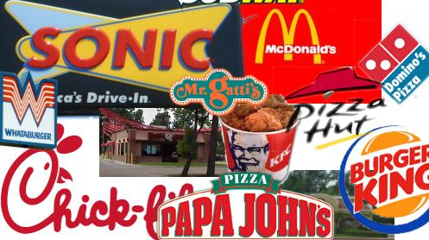
A: Anything else?

B: No thanks.

A: That’ll be 9.95.

B: OK.

Look!

Is that eat in or takeaway?

TAKEAWAY / TAKEOUT (American)= a meal that you buy in a restaurant or shop and take home to eat.

EAT IN = when you buy a meal in the restaurant and you eat it there.

