Lesson 14: Going out

What do you usually do in your free time at the weekend? Do you usually go out? Where?

para agregar texto



What can you do in Buenos Aires at the weekend? Use the phrases from the Vocabulary sheet.

para agregar texto

Did you ever visit England? What places can you visit in London?

para agregar texto

Read

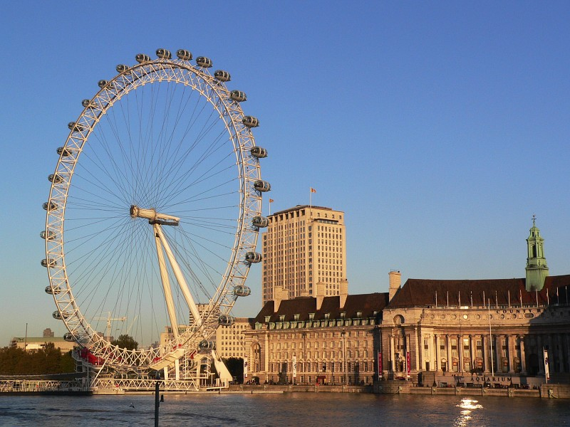

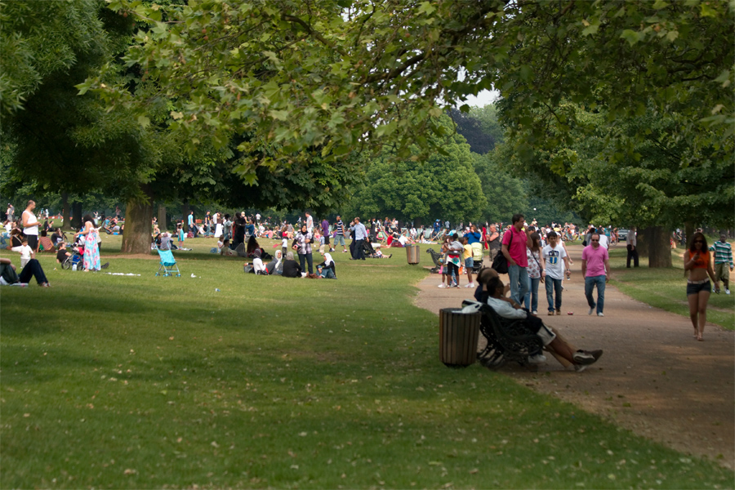

Answer the questions about the article

- How much do you have to pay to visit many of the exhibitions in the National Gallery?
- What do people like to visit when they go to Paris and New York?
- What is special about the views from the London Eye?
- Why is it important to have good weather when you visit the London Eye?
- Why is it "easy to forget that you're in a big city" when you visit Hyde Park?
- What different activities can you do in Hyde Park?
- Why did two million people go to Hyde Park in 2003?

para agregar texto

Think about your future plans. Make notes about:

TONIGHT
para agregar texto

THIS WEEKEND
para agregar texto

NEXT WEEK / MONTH
para agregar texto

LATER THIS YEAR / NEXT YEAR
para agregar texto
REMEMBER!!! This weekend I'm going to... / I'm visiting...

WRITING: Invitations

Read the emails

Find two phrases for inviting and two responses in the emails

para agregar texto



Write emails with the prompts

para agregar texto

para agregar texto

Now it's your turn to write an email to a friend. Make suggestions. Use the previous emails as a model.

para agregar texto

