Lesson 22: How much water do you drink?

Answer

What's your favourite drink?
Do you like alcoholic drinks?
What do you usually drink at night?
What do you usually drink in summer?
How much water do you drink?

Read the introduction to an article:

Answer the questionnaire

Complete the questions with how much or how many.

- (menu: How much, How many) litres of water do you drink?
- (menu: How much, How many) mineral water do you drink?

Look at the pictures

Read the sentences and match them with the pictures A-D.

- I don't drink any water. (menu: A, B, C, D)
- I don't drink much water. (menu: A, B, C, D)
- I drink quite a lot of water. (menu: A, B, C, D)
- I drink a lot of water. (menu: A, B, C, D)



Complete the questions with HOW MUCH / HOW MANY.

- (menu: How much, How many) cups of coffee do you drink a day?
- (menu: How much, How many) milk do you drink a day?
- (menu: How much, How many) glasses of wine do you drink a day?
- (menu: How much, How many) cups of tea do you drink a day?
- (menu: How much, How many) fruit juice do you drink a day?
- (menu: How much, How many) beer do you drink a day?
- (menu: How much, How many) mineral water do you drink a day?
- (menu: How much, How many) Coke do you drink a day?

Now answer the questions about you.

Read about these records.
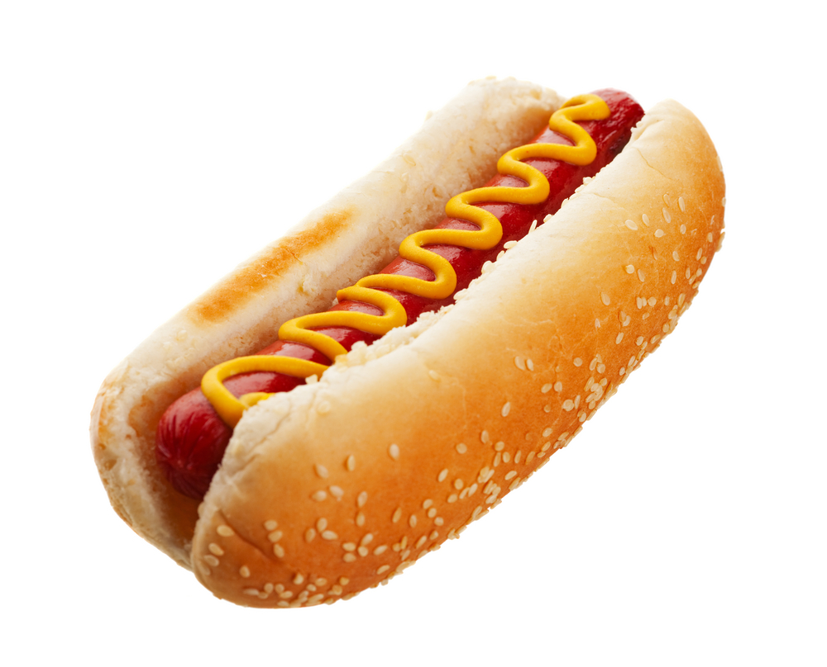
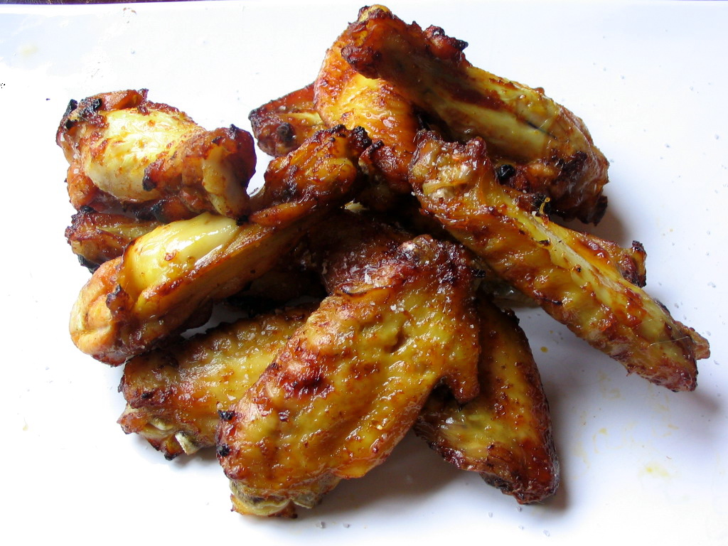
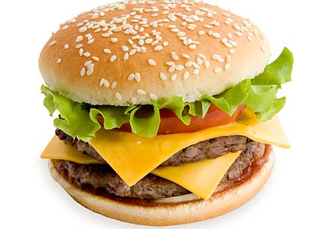
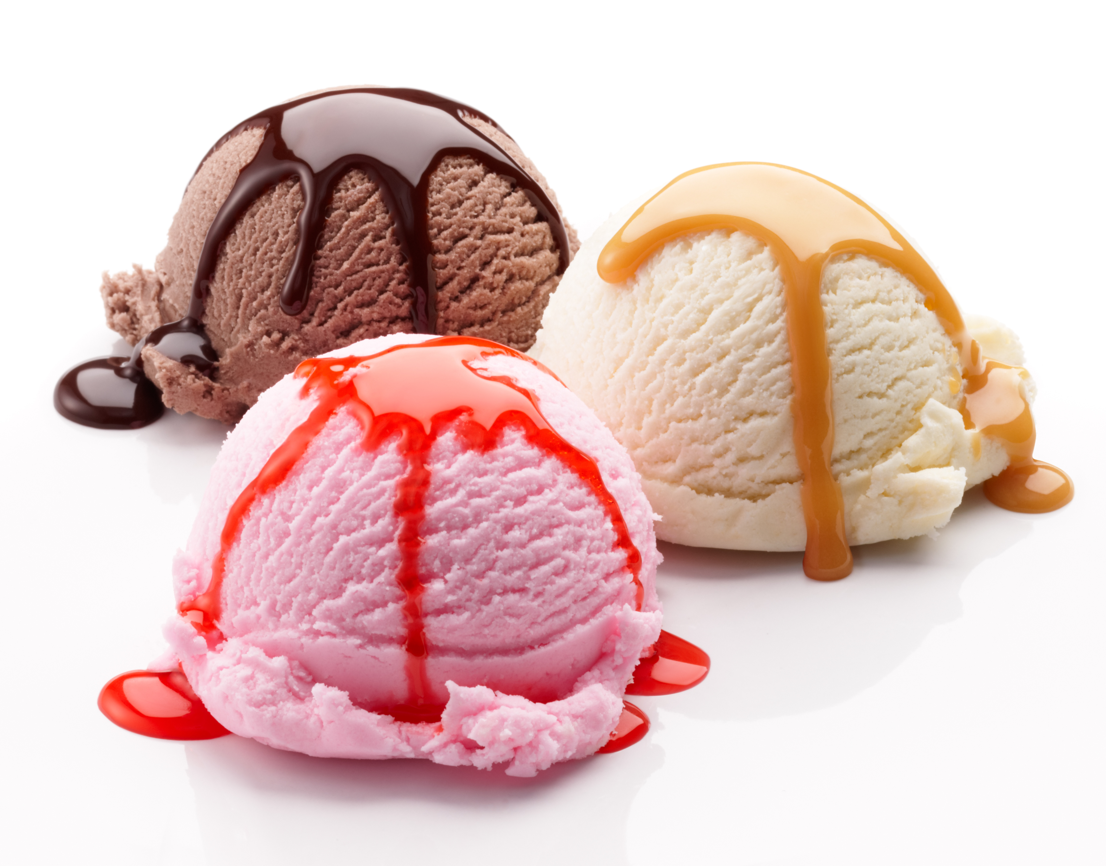
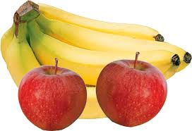
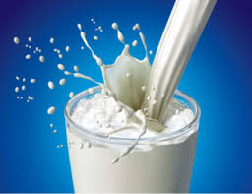

Write questions.

For example, How many hamburgers did Nikolai Cohen eat?

Read the following questions. Do you know the answers?

- Why do we need to drink water?
- Do people need less water when the weather is cold?
- Can we drink too much water?
- Can we get the water we need from other drinks or food?
- How much water do we need to drink a day?
- Do Coke and coffee make us dehydrated?

The answers are in the following article:

Read and choose which question is answered in each text:

B (menu: 1, 2, 3, 4, 5, 6)

C (menu: 1, 2, 3, 4, 5, 6)

D (menu: 1, 2, 3, 4, 5, 6)

E (menu: 1, 2, 3, 4, 5, 6)

F (menu: 1, 2, 3, 4, 5, 6)

VOCABULARY
Write the phrases next to the definitions:

- How hot or cold it is.
- When water comes out of your body.
- When you are hot.
- Scientists do these.
- Not a long time ago.
- Things people believe which are not true.
- A minimum of.
- Have in it.
- The truth is.

PRACTICE

http://elt.oup.com/student/englishfile/elementary/a_grammar/file07/grammar07_b01?cc=ar&selLanguage=en

http://elt.oup.com/student/englishfile/elementary/a_grammar/file07/grammar07_b02?cc=ar&selLanguage=en

