Lesson 24: Festivals

What are your favourite festivals?
When are they?

Look at the photos. Do you know these festivals? Where are they?

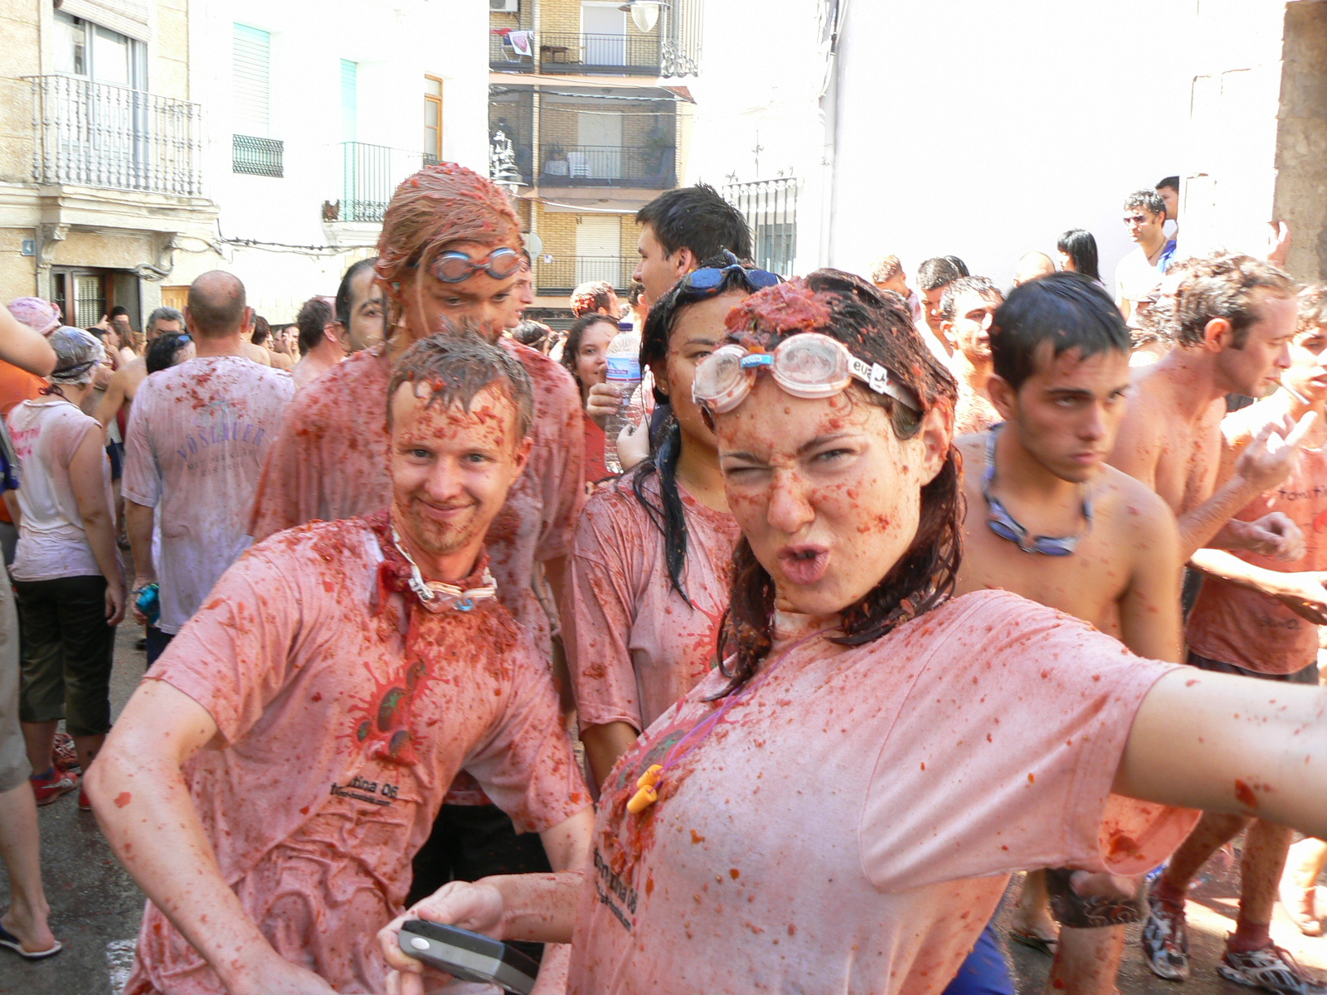
1

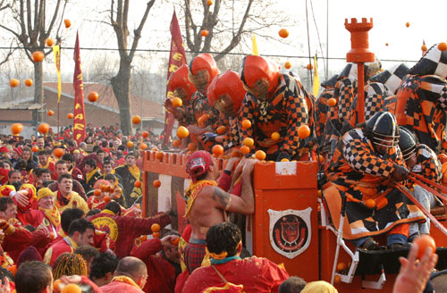
2

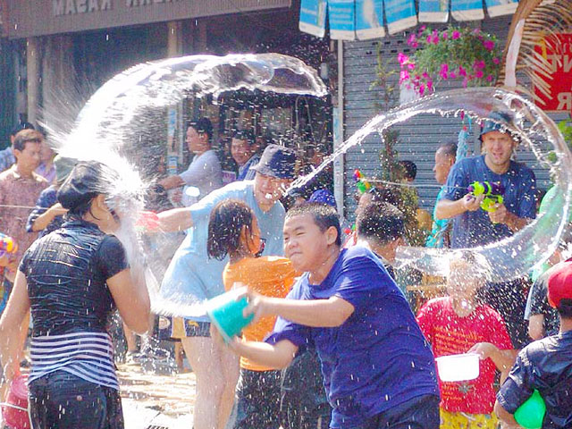
3

Useful language:

- I think number 1 is...
- I don't know.
- I'm not sure but maybe it is...

Read the texts and check your predictions

Fascinating festivals

... but if you go, don't wear new clothes!

What picture is it?

The Tomatina (1, 2, 3)

The Carnevale d'Ivrea (1, 2, 3)

Songkran (1, 2, 3)

Without reading the text, do you remember the information?

Answer:

- Where is The Tomatina?
- When is it?
- What do people throw?

- Where is The Carnevale d'Ivrea?
- When is it?
- What do people throw?

- Where is The Water Festival (Songkran)?
- When is it?
- What do people throw?



Listen to the months in the vocabulary sheet

(track: months)

Listen to the ordinal numbers in the vocabulary sheet

(track: ordinal numbers)

Answer

- When is Halloween?
- When is friend's day?
- When is child's day?
- When's your birthday?
- When is your husband's/ wife's/girlfriend's/boyfriend's birthday?

Writing

Describe your favourite festival/celebration

Remember to include:

- when it is.
- where it is.
- what people do.
- why you like it.

