
Lesson 23: Are you a techie?

A techie: a person who knows a lot about technology.

Look at the pictures. Have you got one? Do you like technology?

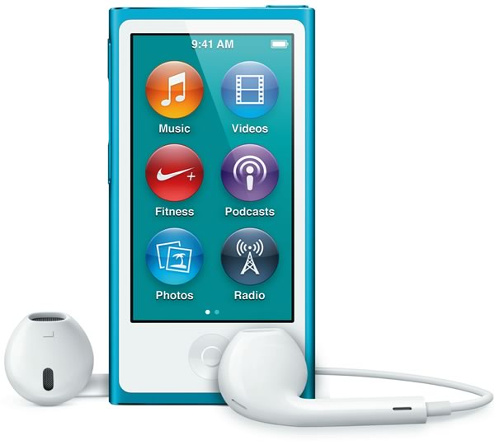
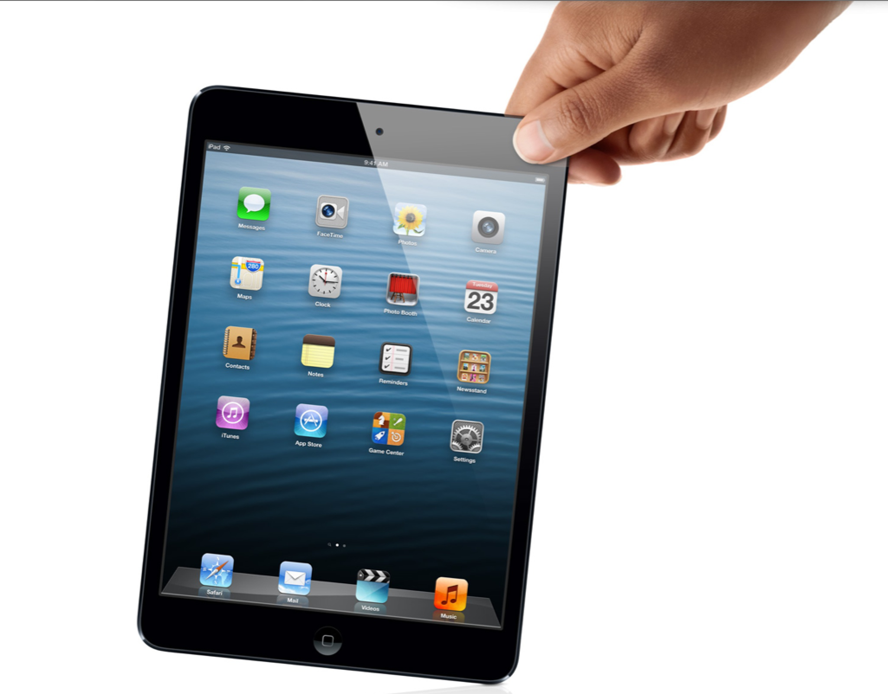

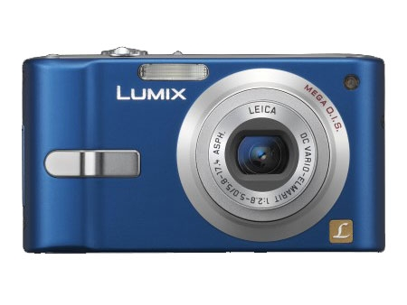

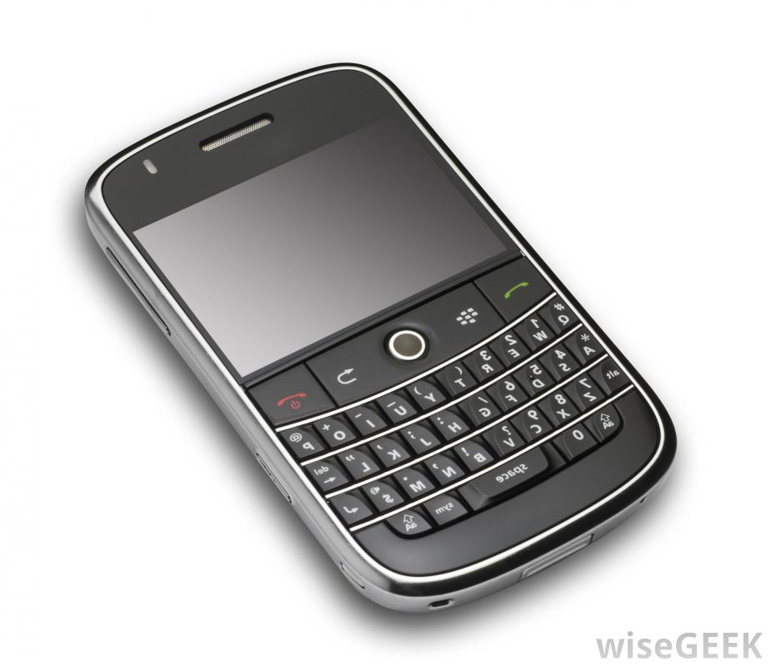

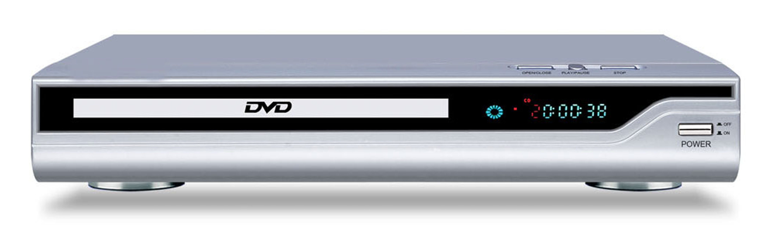

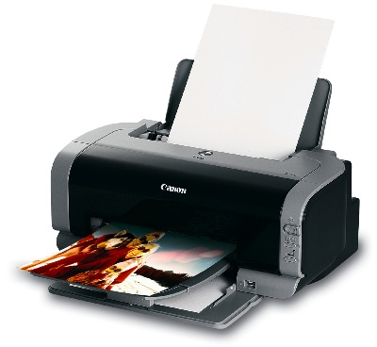



QUIZ

Choose a, b or c

- HOW MUCH TIME DO YOU SPEND ONLINE A DAY?

a) 6+ hours.
b) 2-5 hours.
c) 0-2 hours.

1 (menu: a, b, c)

- DO YOU HAVE A MOBILE PHONE?

a) Yes, I can't live without it.
b) Yes, but I have it for emergencies.
c) No, and I don't want one.

2 (menu: a, b, c)

- YOU NEED INFORMATION. WHERE DO YOU GET IT FROM?

a) The Internet.
b) A book, an encyclopedia or the library.
c) A member of your family.

3 (menu: a, b, c)

- DO YOU SHOP ONLINE?

a) Yes.
b) No, but maybe I can do it.
c) No. The Internet isn't safe.

4 (menu: a, b, c)

- YOU HAVE TWO HOURS' FREE TIME. WHAT DO YOU DO?

a) I surf the Internet.
b) I read the newspaper or a magazine.
c) I do exercise.

5 (menu: a, b, c)

- HAVE YOU GOT AN EMAIL ADDRESS?

a) Yes, I've got many email addresses and my own website.
b) Yes, but I don't use it much.
c) No, I don't need one.

6 (menu: a, b, c)

- WHAT DO THE LETTERS WWW IN WEB ADDRESSES MEAN?

a) World Wide Web.
b) Maybe they mean World Wide Web.
c) No idea.

7 (menu: a, b, c)

- YOUR FRIEND HAS GOT A NEW DVD PLAYER AND ASKS YOU FOR SOME HELP TO SET IT UP. WHAT DO YOU DO?

a) Help immediately. It's easy.
b) Help, but read the instructions first.
c) Say sorry, it's impossible for you.

8 (menu: a, b, c)

Now count your answers.

Read the results.

Read the dialogue.

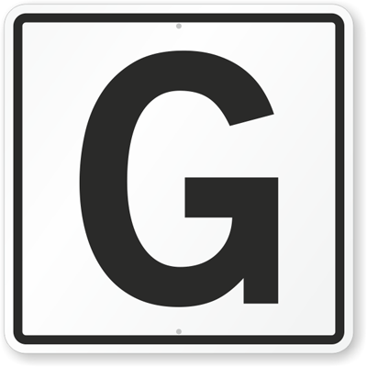

Favourite things

Read the texts

Write a similar text about your favourite object.

- Use adjectives (fast, modern, expensive, fantastic, colours, etc.)
- Use have got, nationalities, etc.

PRACTICE

http://elt.oup.com/student/naturalenglish/elem/a_grammar/unit02/ne_elem_grammar02_1?cc=ar&selLanguage=en&mode=hub

http://elt.oup.com/student/naturalenglish/elem/b_vocabulary/unit02/ne_elem_vocabulary02_1?cc=ar&selLanguage=en&mode=hub

