Lesson 14: Going out

What do you usually do in your free time at the weekend? Do you usually go out? Where?



What can you do in Buenos Aires at the weekend? Use the phrases from the Vocabulary sheet.

Did you ever visit England? What places can you visit in London?

Read

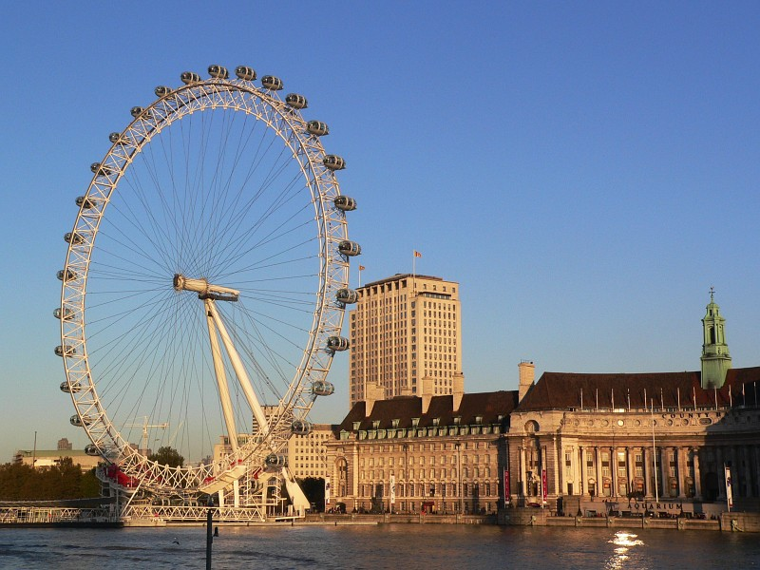

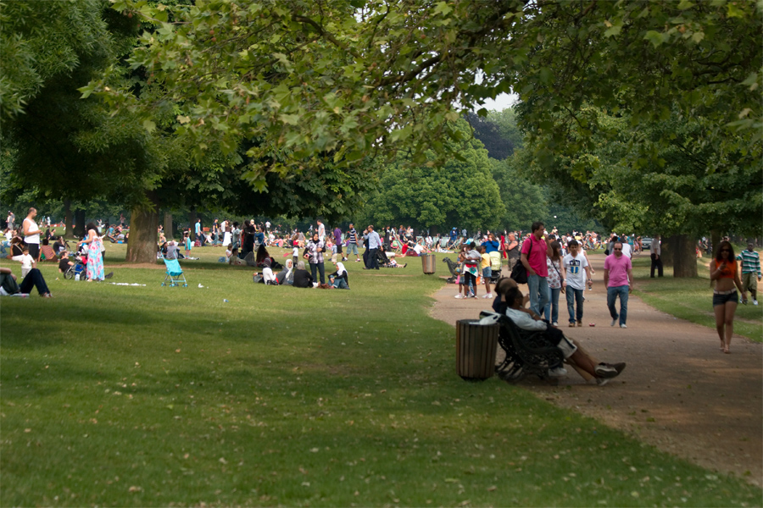

Answer the questions about the article

- How much do you have to pay to visit many of the exhibitions in the National Gallery?
- What do people like to visit when they go to Paris and New York?
- What is special about the views from the London Eye?
- Why is it important to have good weather when you visit the London Eye?
- Why is it "easy to forget that you're in a big city" when you visit Hyde Park?
- What different activities can you do in Hyde Park?
- Why did two million people go to Hyde Park in 2003?

Think about your future plans. Make notes about:

TONIGHT

THIS WEEKEND

NEXT WEEK / MONTH

LATER THIS YEAR / NEXT YEAR

REMEMBER!!! This weekend I'm going to... / I'm visiting...

WRITING: Invitations

Read the emails

Find two phrases for inviting and two responses in the emails



Write emails with the prompts

Now it's your turn to write an email to a friend. Make suggestions. Use the previous emails as a model.

