Lesson 21: A day in the life of James Blunt

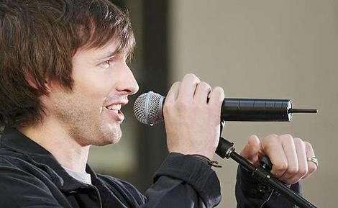
Do you know James Blunt?

Where is he from?

What does he do?

Look at the vocabulary that appears in the text below

Read

Answer the questions

Remember! He lives ... He wears ...

- Where does James live?
- What time does he get up?
- What clothes does he wear?
- Does he have breakfast?
- What does he do in the morning?
- What does he have for lunch?
- What does he do after lunch?
- Does he watch TV?
- What does he do in the evening?

Look at the "time words" in the text



Complete the sentences with a "time word".

- I get up at 7.00. I have breakfast.

- I go out in the evenings, I usually go out to a bar.

- I never drink coffee dinner.

- I always have a shower I go to bed.

- At the weekend I go to bed at half past eleven.

Now write about your typical day. Use "time words".

PRACTICE

http://elt.oup.com/student/englishfile/beginner/a_grammar/file04/grammar04_01a?cc=ar&selLanguage=en

