Lesson 16: Neighbours

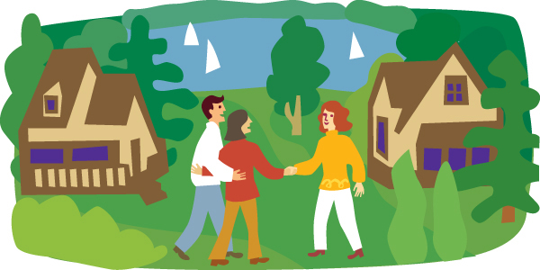
They are neighbours.

Answer

Read the text about neighbours:

These are the top eight problems people have with their neighbours:


- They talk loudly.
- Their babies cry.
- They have noisy parties.
- Their dogs bark.

- They watch TV late at night.
- They move furniture.
- They play a musical instrument.
- They argue with their partner.

What do your neighbours do?

Look at the picture of a block of flats

What's happening in each flat?

Write the numbers of the flats:

He's listening to music.

The baby's crying.

They're having a party.

She's playing the violin.

The dog's barking.

They're arguing.

He's watching football.

They're moving furniture.



What's happening? Listen and write sentences.

(track: noises)

Listen to a man on a mobile phone. Write the six Present Continuous sentences you hear.

(track: man on a mobile)

PRACTICE

http://elt.oup.com/student/englishfile/elementary/a_grammar/file06/grammar06_c01?cc=ar&selLanguage=en

http://elt.oup.com/student/englishfile/elementary/a_grammar/file06/grammar06_c02?cc=ar&selLanguage=en

